**Unveiling Marketing Insights**

**Project Report**

**1.INTRODUCTION**

1.1 Overview

1.2 Purpose

**2.PROBLEM DEFINITION AND DESIGN THINKING**

2.1 Empathy map

2.2 Ideation and Brainstorming map

**3.RESULT**

3.1 Data Model

3.2 Activity and Screenshot

**4.ADVANTAGES AND DISADVANTAGES**

**5.APPLICATIONS**

**6.CONCLUSION**

**7.FUTURE SCOPE**

1.INTRODUCTION

1.1 OVERVIEW:

The goal of the field of market insights is to learn about and analyse the market. Data on the market, consumers, and competitors must be gathered, analysed, and interpreted by individuals in this role. Their main objective is to give important information and viewpoints to company decision-makers, helping them to make wise decisions and create plans.

Working in the field of market insights requires a special set of skills which allow both efficient market research and the creation of insightful data. Here are some qualities everyone should have: Analytical thinking, Curiosity, Excellent communication skills, creativity.

1.2 PURPOSE:

1.Analytical Thinking: A Market insights expert must be able to break down data and draw out relevant information. Its essential to have the ability to differentiate between hidden patterns ana a broader context.

2.curiosity: This quality is maybe the most crucial. The key to success in this industry involves possessing a strong drive to investigate unique trends, go into unknown territories, and understand customer behaviour.

3.Excellent communication skills: you must be able to clearly and persuasively present your findings while working with company decision-makers and data. You must be effective communicator, verbally and in writing.

2.PROBLEM DEFINITION AND DESIGN THINKING

2.1EMPATHY MAP:

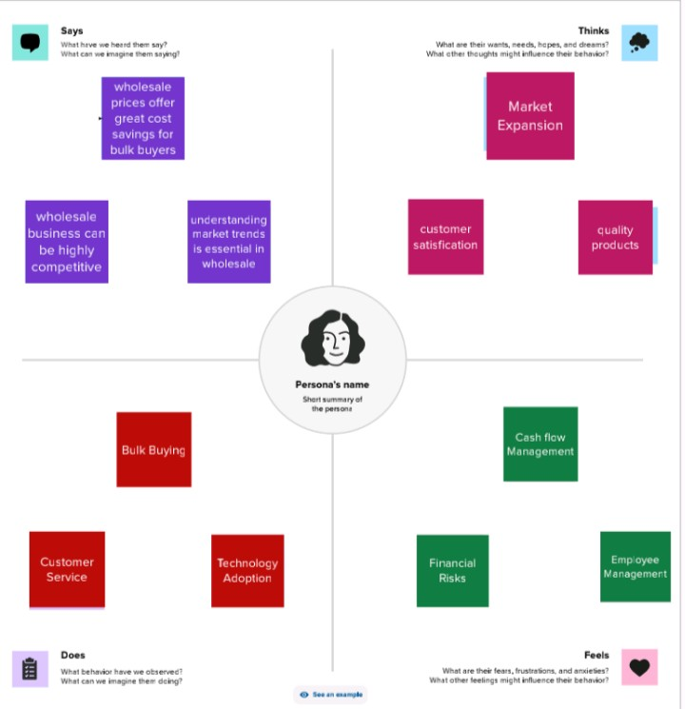

2.2 IDEATION AND BRAINSTORMING MAP:

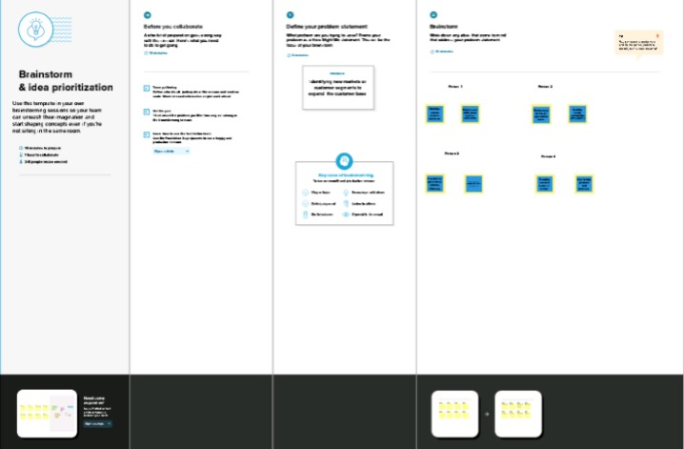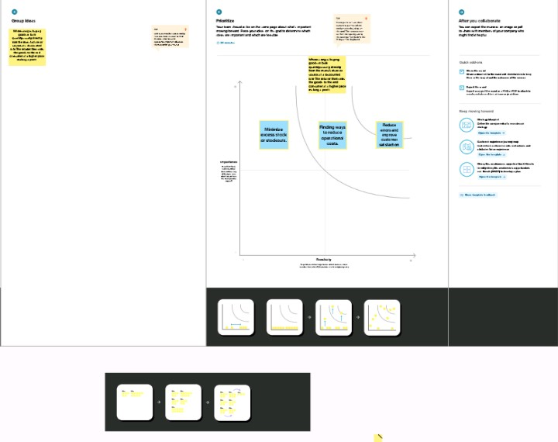

3.RESULT

3.1 Data Model

Specify the business problem

Requirements

Literature Survey

Business Impact

3.2 Activity and Screenshot

**Milestone 1:** Define problem/Problem Understanding

**ACTIVITY 1:** Specify the business problem

How to analysing spending behaviour and identifying opportunities for growth.

**ACTIVITY 2:** Requirements

For this created KPLs and interactive visualizations and dashboard and story board to bring clean and deep understanding of the data.

**ACTIVITY 3:** Literature Survey

The literature survey would include sources such as academic journals, Industry reports, and online articles. It would aim to identify key performance indicators (KPIs) and metrics that are commonly used to measure wholesale customers.

**ACTIVITY 4:** Business Impact

REVENUE GROWTH: Leveraging market insights to identify growth opportunities can lead to increased sales and revenue for businesses.

COST OPTIMIZATION: Data-driven decision-making allows businesses to allocate resources more efficiently.

**Milestone 2:** Data collection and Extraction

Data collection is the process of gathering and measuring information on variables of interest, in an established systematic fashion that enables one to answer stated research questions, test hypothesis and evaluate outcomes and generate insights from the data.

**ACTIVITY 1:** Collect the data

<https://docs.google.com/spreadsheets/d/16r4VuN2bmsQ_50XvQpzGB5MJ7b6CBV-VKwJ0ZjePKUk/edit?usp=drivesdk>

use the link to download the dataset.

**ACTIVITY 1.1:** Understand the data

Data contains all the meta information regarding the columns described in the CSV file. We have provided CSV file:

Wholesale Customer Data.CSV

COLUMN DESCRIPTION

REGION and CHANNEL: It is dimension data in wholesaler data.

FRESH: It is a product in data and it measure the selling quantity of fresh.

MILK: It is measured and shows the quantity of selling milk.

GROCERY: Combination of products used to prepare food comes under measure.

FROZEN: Food that has been subjected to rapid freezing and it is measured.

DETERGENT PAPER: It is also a measure in the wholesaler customer data

DELICASSEN: IT is also one of the products sold by the wholesaler.

**ACTIVITY 2:** Connecting Dataset to Tableau.

Open a tableau

Add the data set file in the text option and the data set will be connected.

**MILESTONE 3:** Data preparation

**ACTIVITY 1:** Prepare the data for visualization

Here the dataset is available and the visualization are showed in the activity.

**MILESTONE 4:** Data Visualization

Data visualization is the process of creating graphical representations of data. By using visual elements such as charts, graphs, and maps, data visualizations can help people quickly identify patterns, trends, and outliers in the data.

**ACTIVITY 1:** No of unique visualizations

It can be created by using a given dataset. The types of visualization can be used to analyse the performance and efficiency of a project include bar charts, line charts, heat maps, scatter plots, pie charts, maps etc…

**ACTIVITY 1.1:** Milk KPLs



Taking milk and drag text and go to text.

Give the heading as giving milk and select the size of letters given bold letters you can see the KPL of milk.

Grocery KPLs

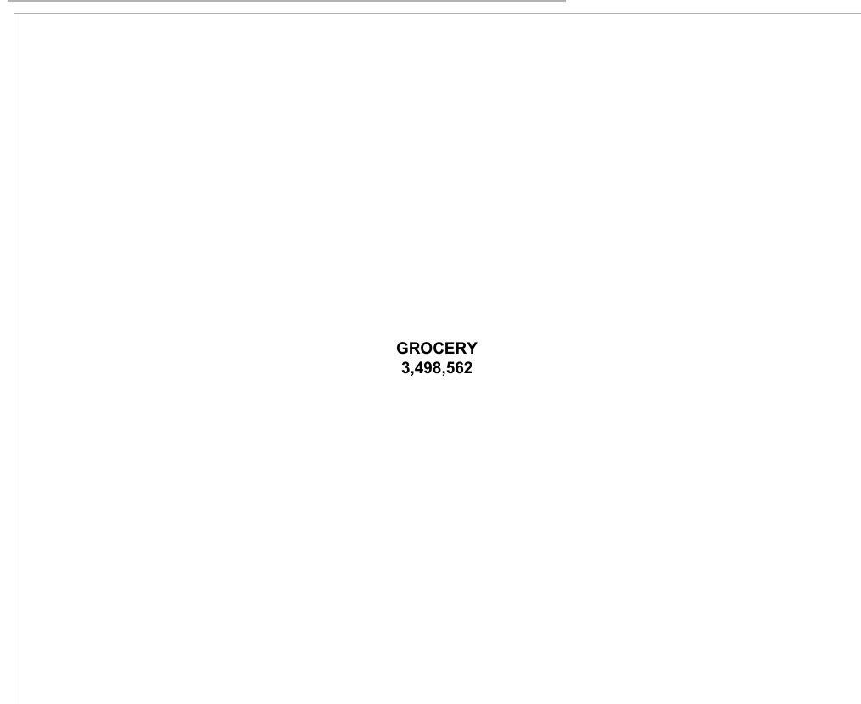

Grocery drag in text and give the heading as grocery give bold letters.

Frozen KPLs

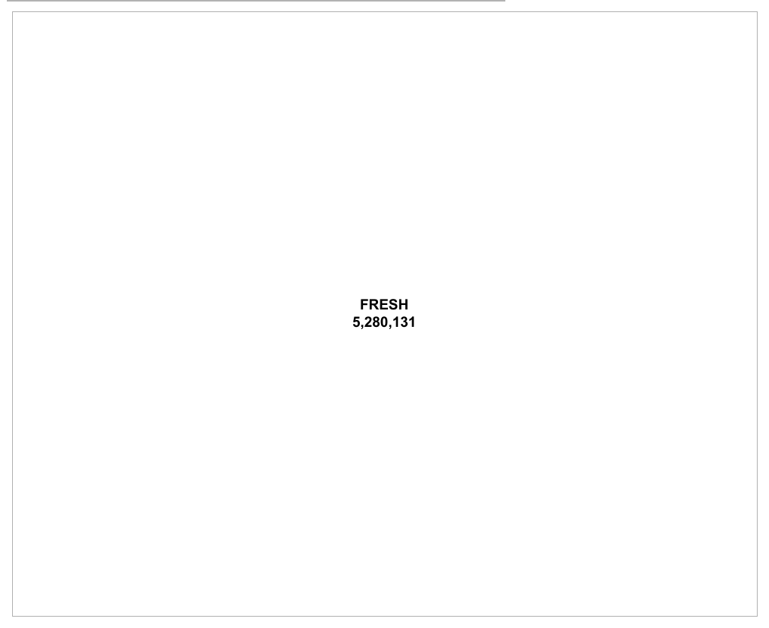

Drag the fresh and go to text and give the heading as fresh in bold letters.

Region wise detergent paper and grocery.

**ACTIVITY 1.2:** Region wise detergent paper and grocery

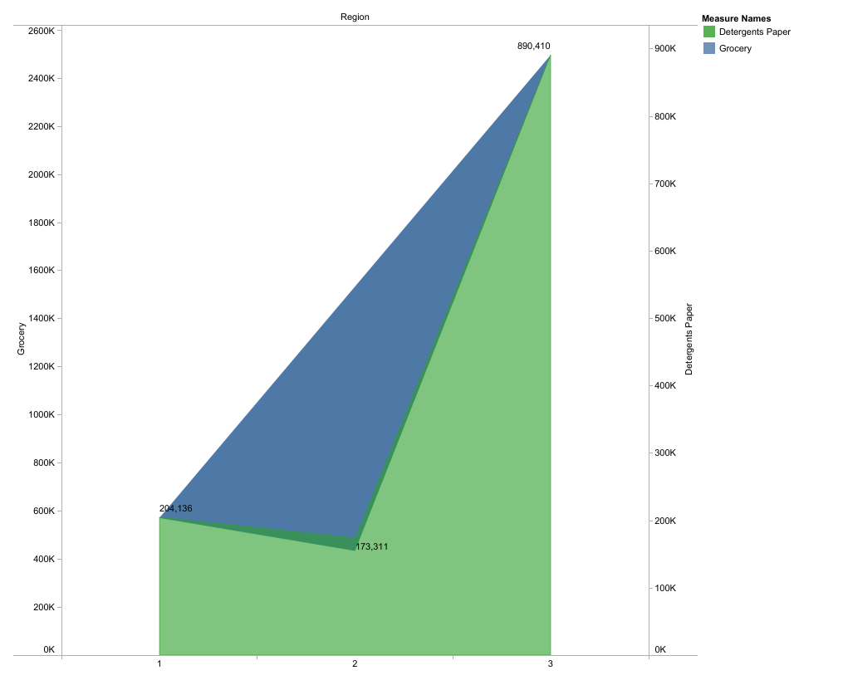

Region covert into dimension and channel also to dimension region in row and grocery in column and detergent paper in also column. Make dual access and entire view and select polygon in grocery and area in detergent paper. The region wise detergent paper and grocery will be viewed.

**ACTIVITY 1.3:** Region wise milk

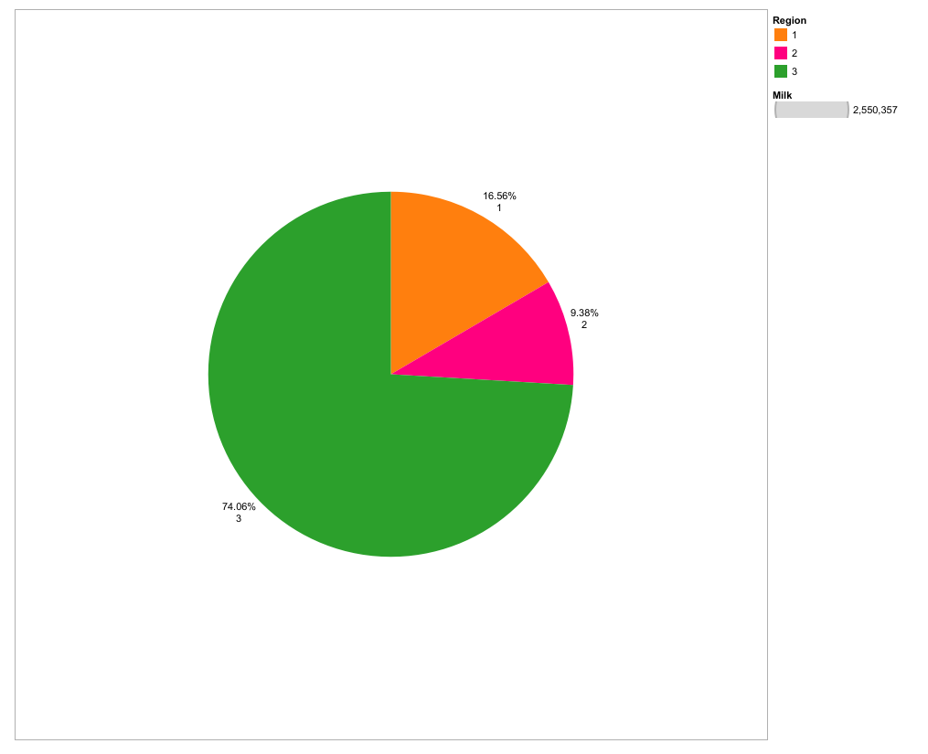

Select region and drag in column and milk in row that will show the milk measure and click show me on right corner select circle graph and click centre view and click milk in size and label and add table calculation, click percent of total and click region and drag in label. You can see the milk percentage.

**ACTIVITY 1.4:** Channel wise frozen and delicatessen

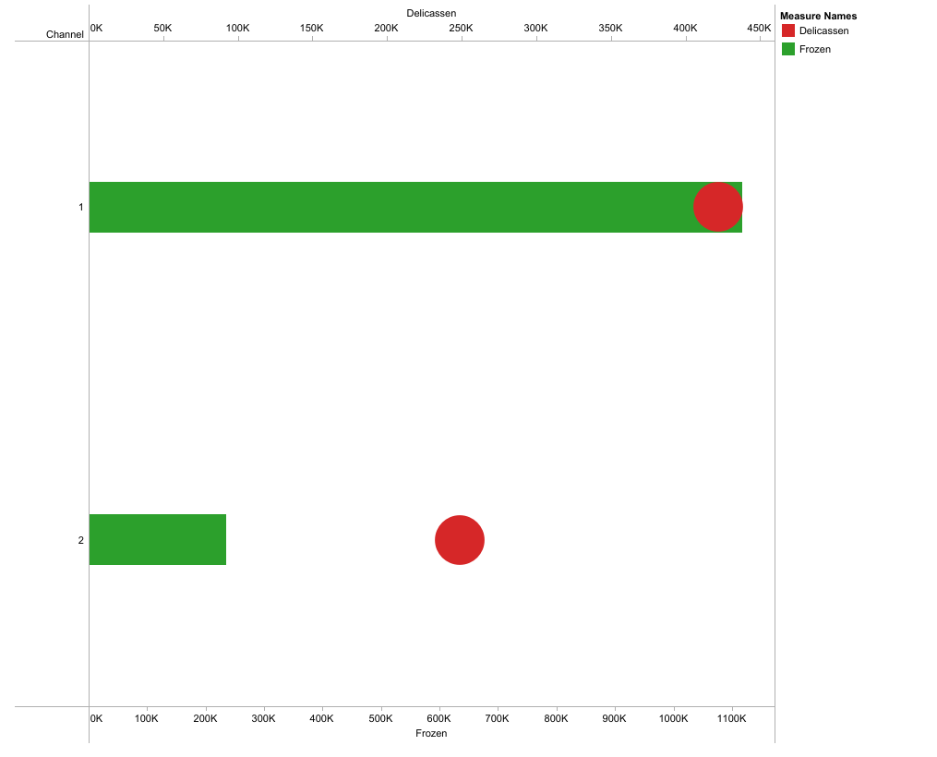

Take channel in row and frozen in column. Make it dual access and entre view. Choose colour in automatic as bar. Change bar size edit colour also for frozen same as the delicatessen as circle and change colour of circle.

**ACTIVITY 1.5:** Region wise delicatessen and detergent paper

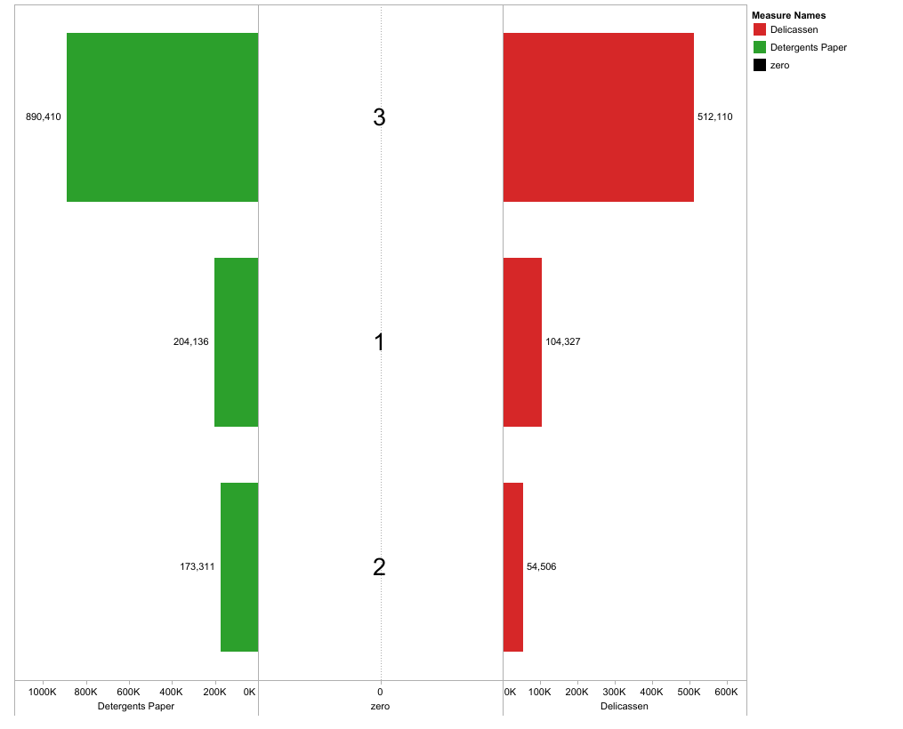

Taking Region in column and taking detergent paper and delicatessen in row. Create calculator field edit calculator as zero. Drag zero to row.

Make it dual access drag zero from row to column and also choose delicatessen in column.

**ACTIVITY 1.6:** Channel wise grocery and detergent paper

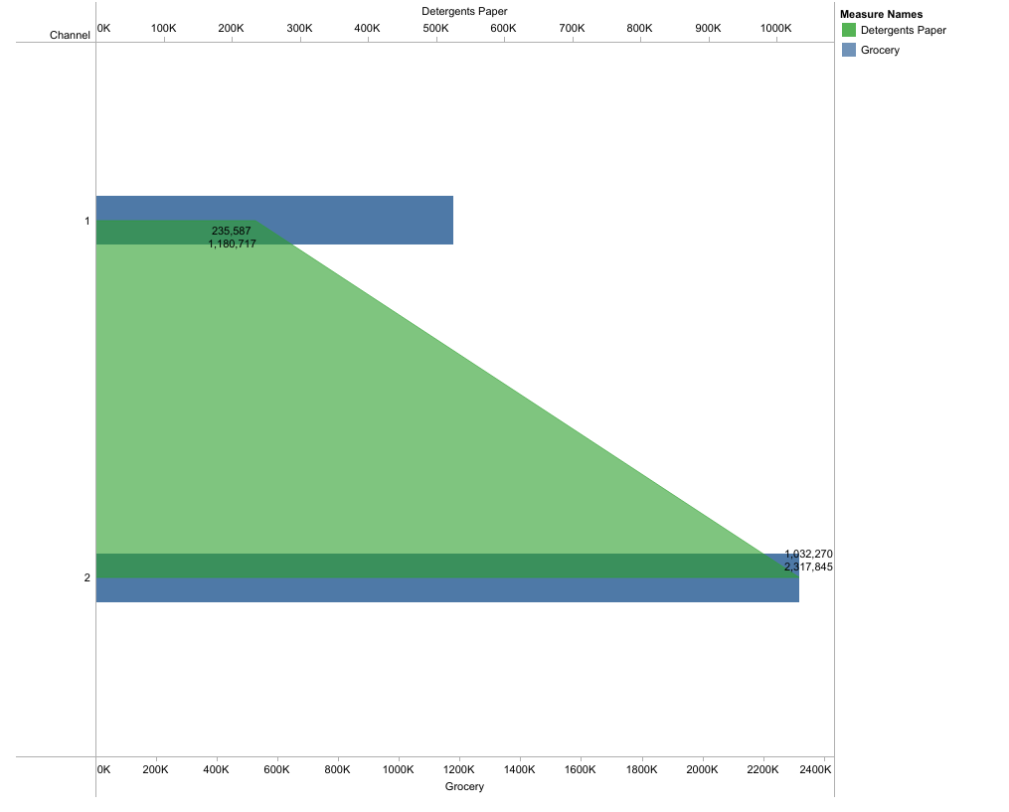

Drag the channel in to the row and grocery, detergent paper into the columns Making it dual axis and making it centre view, Then change colour and size of a graph. Drop the detergent paper, grocery on text. Now you can see channel wise grocery and detergent paper.

**ACTIVITY 1.7:** Region wise delicatessen

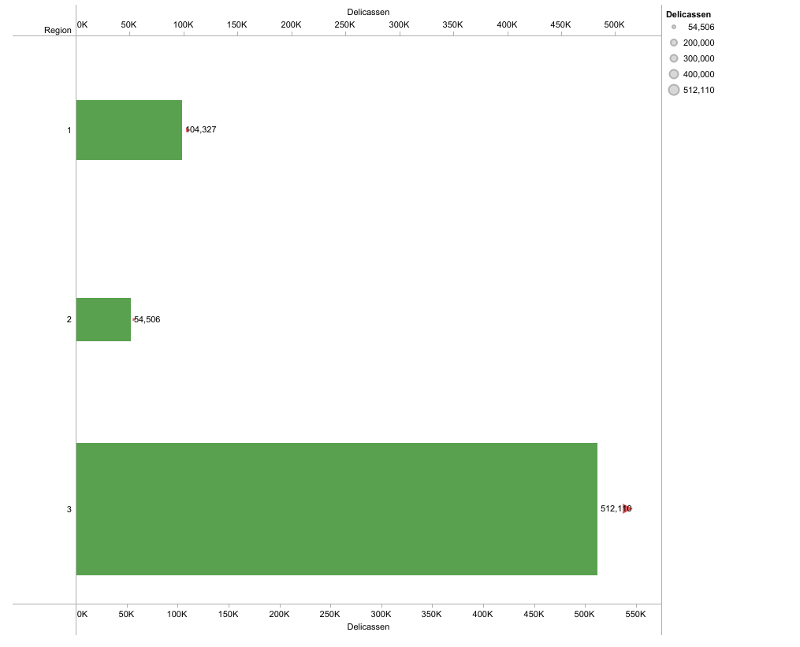

First taking region to rows and delicatessen to columns. Then change colours and size of graph. dropping delicatessen in the text. Now you can see region wise delicatessen.

**MILESTONE 5:** Dashboard

Dashboard can be used in a variety of settings, such as business, finance, manufacturing, healthcare, and many other industries. They are can be used to track key performance indicators (KPIs), monitor performance metrics, and display data in the form of charts, graphs, and tables.

**ACTIVITY 1:** Responsive and design of dashboard

. The goal is to create a dashboard that is user-friendly, interactive, and data-driven, providing actionable insights to analyse vehicle collisions.

Once you have created views on different sheets in Tableau, you can pull them into a dashboard.

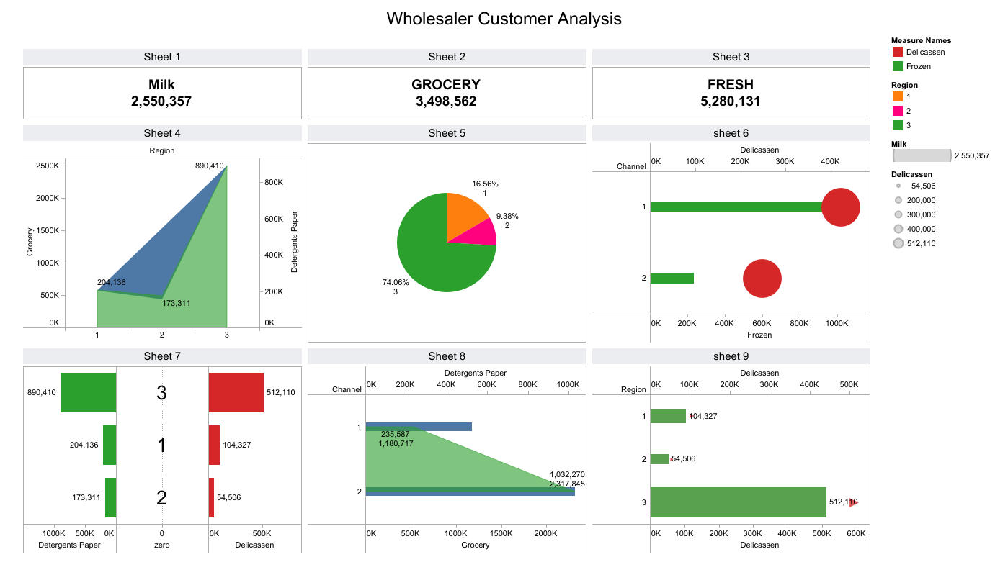

**Milestone 6:** Story

A data story is a way of presenting data and analysis in a narrative format, with the goal of making the information more engaging and easier to understand. Data stories can be told using a variety of mediums, such as reports, presentations, interactive visualizations, and videos.

**ACTIVITY 1:** No of scenes of story

A story board is a visual representation of the data analysis process and it breaks down the analysis into a series of steps or scenes.

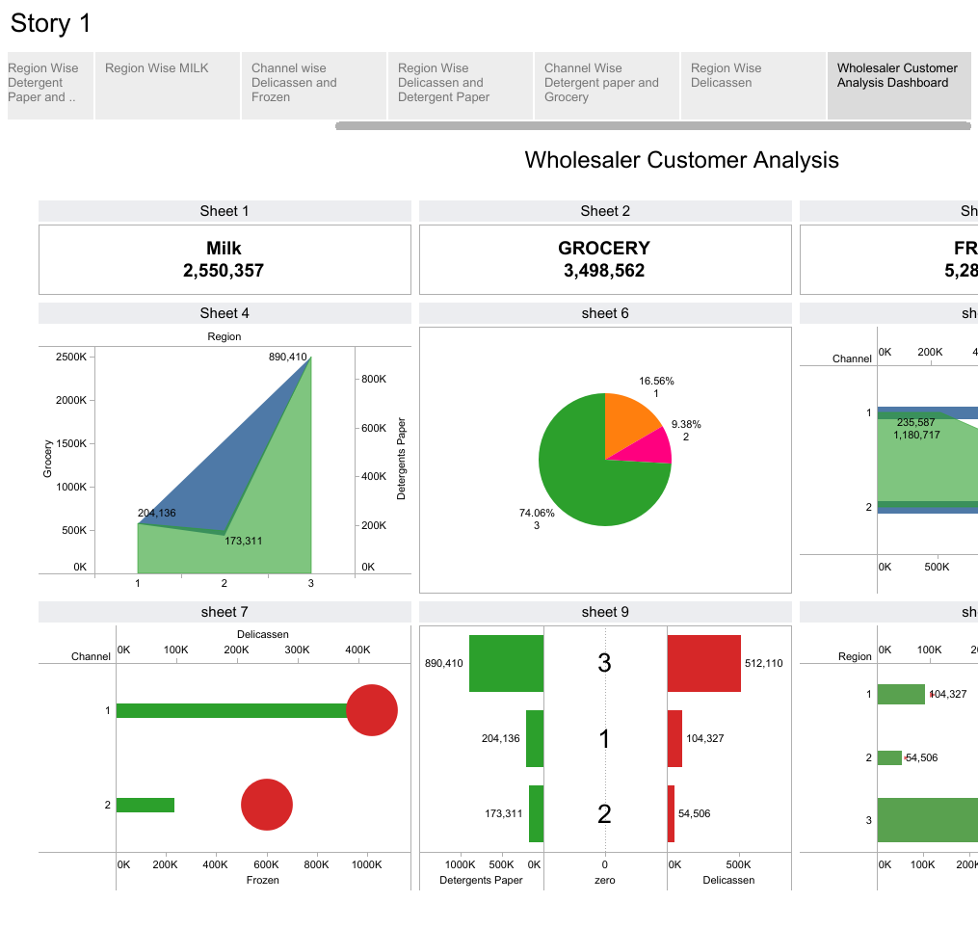

**MILESTONE 7:** Performance Testing

**ACTIVITY 1:** Amount of Data Rendered to Tableau

The amount of data that is rendered to a tableau depends on the size of the dataset.

**ACTIVITY 2:** Utilization of data filters

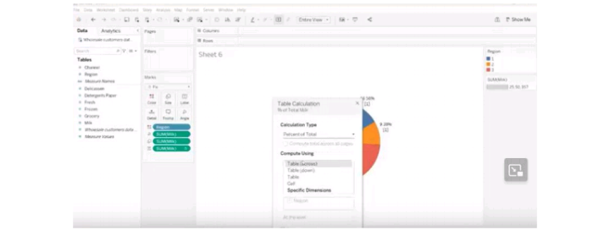

**ACTIVITY 3:** No of calculation fields

Delicatessen

Detergents paper

Fresh

Grocery

Milk

Zero

Wholesale Customer Data…

Measure Values

**ACTIVITY 4:** NO OF VISUALIZATION/GRAPHS

1.KPL

2.Region Wise Detergent Paper and Grocery

3.Region Wise Milk

4.Channel Wise Frozen and Delicatessen

5.Region Wise Delicatessen and Detergent Paper

6.Channel Wise Grocer and Detergent Paper

7.Region Wise Delicatessen

**MILESTONE 8:** PUBLISHING

Publishing helps us to track and monitor key performance metrics, to communicate results and Progress. Help a Publisher stay informed, make better decisions, and communicate their performance to others.

PUBLISHING DASHBOARD AND REPORTS TO TABLEAU PUBLIC

STEP-1: Go to Dashboard/story, Click on share button on the tob ribbon.

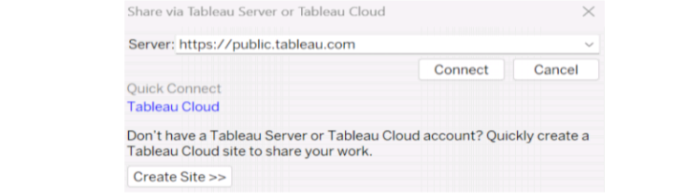

Give the server address of your tableau public account and click on connect.

STEP-2: Once you click on connect it will ask you for tableau public user name and password.

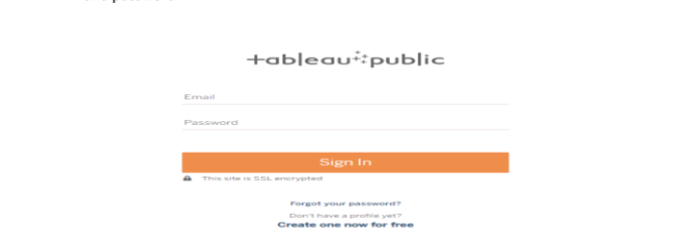

Once you login into your tableau public using the credentials, the particular visualization will be published into tableau public.

NOTE: while publishing the visualization to the public, the respective sheet will get published when you click on share option.

4.ADVANTAGES AND DISADVANTAGES

Advantages:

Marketing that is properly researched and targeted will bring new and returning customers.

Opinions of current and former customers can identify areas for improvement.

Raising brand awareness.

Allows for a more personal relationship between the business and the customer.

Increased market share.

Disadvantages:

Marketing can be expensive and drain profits, especially for smaller business.

It is difficult to accurately assess the cost benefit of a marketing campaign.

Not all campaigns are successful because they were not carefully researched and planned.

The business may require additional staff to assist with advertising.

The cost of branded items used for advertising reduces profit margins.

The items require to keep information updated on websites and social media may require additional staff.

5.APPLICATIONS

The most advanced forms of marketing insight provide data and actionable, meaningful insights that can be used immediately and almost instantly to yield positive results.

It would help if you had a staff dedicated to examining such insights and determining how to implement those ideas. However, these insights will assist you in making the decisions motivated by the data necessary to achieve your goals.

Examining their marketing attribution reports is a typical strategy marketers use to gain insights from these analytics tools. Marketing attribution is valuable since it can analyse all the marketing interactions that contributed to your sales and provide information on which interactions were most essential and where they landed in your marketing funnel.

6.CONCLUSION

We have tried to give you the details about marketing insight and its importance. One of the most important benefits of marketing insights we learned is that it will strengthen the relationship between marketers and customers by providing the details needed to solve marketing problems and assist with marketing policy.

Understanding customer behaviour and attitudes are essential to developing effective marketing strategies.

If you need help conducting marketing insights research, contact the question pro team of experts. Question pro can help you navigate the process and make the most of your data.

7.FUTURE SCOPE

Marketing analytics allow you to gather deeper consumer insights, optimize your marketing objectives, and get a better return on investment. Marketing analytics benefits both marketers and consumers.

In the future of marketing analytics, one of the main trends would be the wider use of automation. Business will focus more on social media channels and use more third-party data for data-driven decisions. There will be better customer engagement and retention as well.

Marketing strategies help brands stand out and ensure that their products or services are the consumers first choice.

PROJECT LINK

Team Leader:

Dashboard Link:

<https://public.tableau.com/app/profile/afrin.fathima.a/viz/WholesalerCustomerAnalysis_16954487857110/Dashboard1?publish=>

Story Link:

<https://public.tableau.com/app/profile/afrin.fathima.a/viz/WholesalerCustomerAnalysis___/Story1?publish=yes>

Team Member 1:

Dashboard Link:

<https://public.tableau.com/app/profile/deva.dharshni.j/viz/WholesaleCustomerAnalysis_16954635610000/Dashboard1?publish=yes>

Story Link:

<https://public.tableau.com/app/profile/deva.dharshni.j/viz/WholesaleCustomerAnalysis_16954635610000/Story1?publish=yes>

Team Member 2:

Dashboard Link:

<https://public.tableau.com/app/profile/akalya.murugesha/viz/milk_Dashboard1/Dashboard1?publish=yes#WelcomeQuestionnaire>

Story Link:

<https://public.tableau.com/app/profile/akalya.murugesha/viz/milk_story1/Story1?publish=yes#WelcomeQuestionnaire>

Team Member 3:

Dashboard Link:

<https://public.tableau.com/app/profile/akalya.murugesha/viz/milk_Dashboard1/Dashboard1?publish=yes#WelcomeQuestionnaire>

Story Link:

<https://public.tableau.com/app/profile/akalya.murugesha/viz/milk_story1/Story1?publish=yes#WelcomeQuestionnaire>

**MILESTONE 9:** PROJECT DEMONSTRATION AND DOCUMENTATION:

Below mentioned deliverables to be submitted along with other deliverables

ACTIVITY 1: Record explanation video for the projects end to end solution.

Demo Video Link:

<https://drive.google.com/file/d/1-CjGp7dtT4B1X0pajxx4D3PzN_CkOUAQ/view?usp=share_link>

ACTIVITY 2: Project documentations-step by step project development procedure.